Publishing Settings: Articulate Presenter

Tool | Articulate Presenter v0.9
Document Date and Version | 16 May 2014

Brief Summary
This document describes the recommended settings for Articulate Presenter v0.9 when publishing to HR SAP LSO. Two different methods for users to complete the module are included. As there is only SCORM 1.2 running in LSO, only the Settings for SCORM 1.2 are shown.

1. Player Settings
Prior to publishing, ensure the Player settings are correct.

To access the Player Properties click the Player button. | 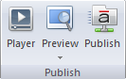
Click Other.  Ensure Prompt to resume is selected. | 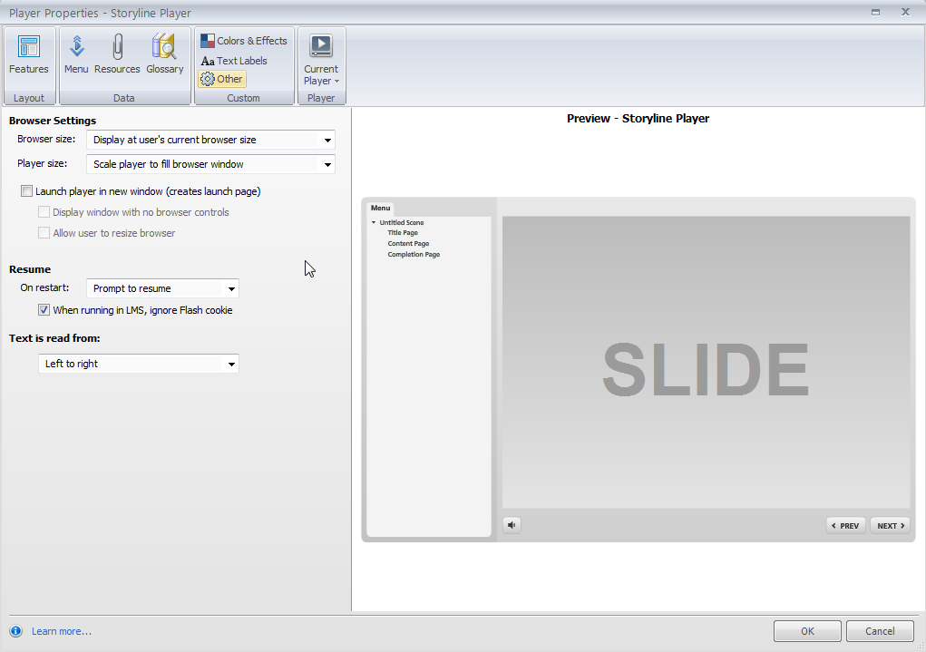

2. Publishing Settings
The module should be published to SCORM 1.2.
Publishing Settings for SCORM 1.2

Click the Publish button. | 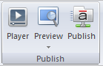
Select the LMS tab.  Select the folder for the published files.  Select SCORM 1.2.  Click the Reporting and Tracking button to edit options. | 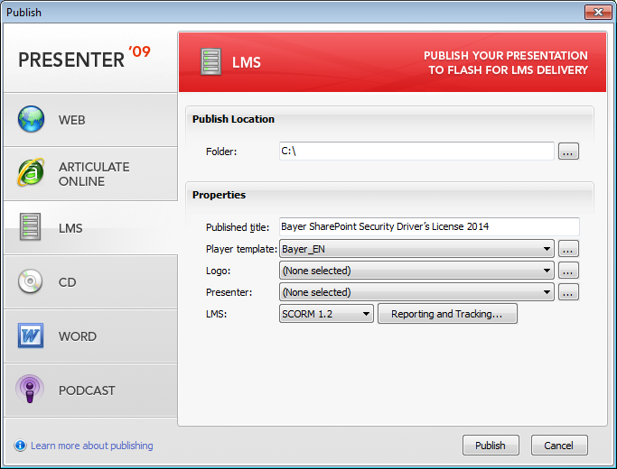
Reporting and Tracking Options

In the Reporting tab ensure Passed/Incomplete is selected for SCORM 1.2. | 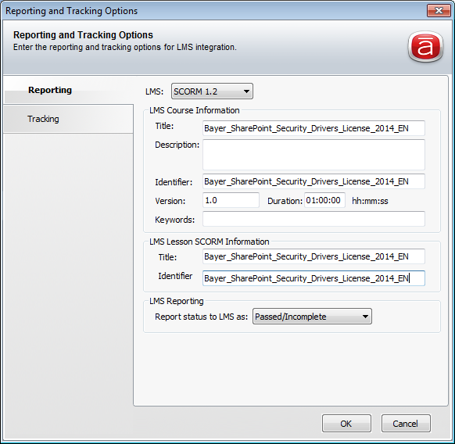
In the Tracking tab, select ‘Track using quiz result’ for completion based on either Quiz Result or Completion button.  Select ‘Track using number of slides viewed’ to specify how many slides the user must view to complete the module.  Select ‘Track using quiz results’ to select the respective quiz the user must pass for the training. The passing score settings are based on the settings that have been done in the quiz area. | 